IBERIAN MUN Historical Security Council
Officer Report 2020
The situation in South Africa (7 November 1962)

Background Information:
In the early 20th century, racial segregation had already been in practice in South Africa. Three years after South Africa gained independence from Britain, the 1913 Land Act was passed, compelling black Africans to leave their areas of residency and live in reserves. As a response, the South African National Native Congress, which later became known as the African National Congress (ANC), was formed.
In later years, the government began to enforce segregation laws as a result of South Africa’s economic decline due to the Great Depression and World War II.

Introduction:
In 1948, an ideology known as apartheid was adopted and implemented by the South African government. The Afrikaans word “apartheid” translates to “apartness” in English; as the name suggests, the series of policies enacted by the government was intended to enforce racial segregation in the country. Over time, the attitude of the South African government towards these policies have not changed: despite the fact that they were originally claimed by the government to serve the purpose of promoting equal and “separate development” of all races as well as creating a means of cultural expression, there were nearly no positive outcomes; under the guise of intending to benefit all racial groups in the South Africa, the government party that had at the time newly risen to power – known as the Afrikaner National Party – in reality established the foundation of discrimination within the country. Additionally, as the National Party consisted solely of white people, which made up the minority of the population in South Africa, it was clear that the implementation of apartheid was primarily aimed against the non-white citizens of the country. This was even more evident in many of the legislations imposed during that period that targeted the majority.

Laws of Apartheid:
In 1950, two years after the National Party took office as the governing party of South Africa, the Population Registration Act was passed. It became mandatory for every citizen to be registered at the Department of Home Affairs based on their racial group. People were given classifications of races including Bantu (black), colored (mixed race), white, and later Asian (Indian or Pakistani); people of different races were then to be treated differently from each other. This law moreover prohibited marriage across different races and aimed to minimize interrace interactions. However, one of the principal flaws of this act was the lack of clear criteria by which South African citizens were classified: it was on occasion difficult to assign racial groups to certain people, which raised issues such as the separation of family members from each other.
In the same year, the Group Areas Act was passed as a follow-up to the Population Registration Act. After citizens were classified into different racial groups, these groups were physically separated under the Group Areas Act, which designated residential and business districts for each race in which people of other races could not own land. Consequently, a significant number of people were forcibly removed from areas in which they had lived or conducted business due to said areas being assigned to a different racial group. Along with two more acts that were passed in 1954 and 1955, the Group Areas Act became one of the new series of Land Acts that, at the end, assigned more than 80% of the land in South Africa for the white minority.
Following the Land Acts, the government implemented the Promotion of Bantu Self-Government Act of 1959, which established ten African homelands called Bantustans. A very small fraction of South Africa’s land was designated as Bantustan territory; many black people were also moved away from land they had owned for a considerable time that was within white areas, including District 6, Sophiatown and Lady Selborne. As an aftermath of this act, the Bantu Homelands Citizenship Act of 1970 forced every black African to live in one of them Bantustans, preventing them from being involved in South African politics and interfering with the government.
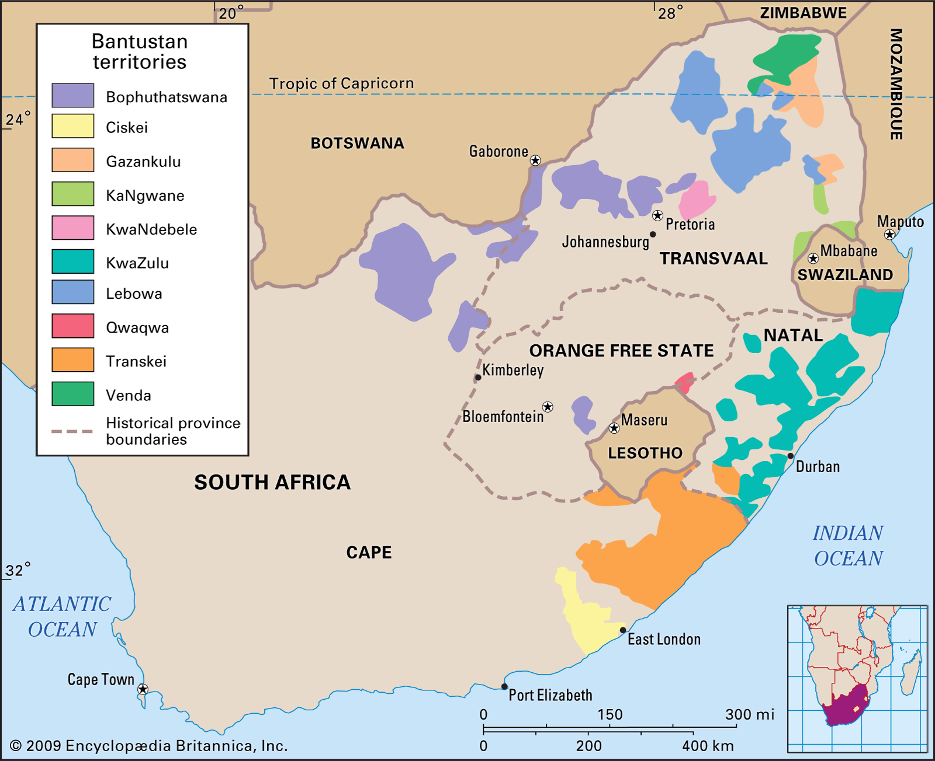
A map of the distribution of Bantustans in and around South Africa
Resistance:
The policies of apartheid unsurprisingly caused public outrage, both within South Africa and in other countries. Foreign opponents of apartheid provided support to organizations that called upon movements in South Africa against the policies. A major one of such organizations was the aforementioned African National Congress, originally established in the 1910s. Initially after apartheid was introduced to South Africa, the ANC organized non-violent protests and strikes. For instance, during a mass meeting in 1952, the people present burned their pass books. In the same year, the ANC created the Defiance Campaign, the participants of which would intentionally break apartheid laws as a form of resistance.
However, the extent of the resistance quickly escalated: in 1960, a group of followers of the Defiance Campaign who were part of the Pan-African Congress (PAC), a branch of the ANC, initiated a demonstration at the police station of Sharpesville by arriving without passes. As a result, at least 67 were killed and 180 were wounded. Thus, the majority of anti-apartheid organizations deemed it necessary to resort to more violent means in order to reach their goals. Many military wings were since established; Nelson Mandela, for example, founded the military wing Umkhonto we Sizwe (“Spear of the Nation”) in the ANC. In a 1961 letter from Mandela to Hendrik Verwoerd, the then-prime minister of South Africa, Mandela threatened that the government could either choose to “accede to our demands and call a National Convention of all South Africans to draw up a democratic Constitution”, or to “persist with the present policies” while the ANC was “resuming active opposition against your regime”.
Though the military wings of anti-apartheid organization had never significantly harmed the state, several of the leaders were arrested or executed during the period of resistance. On August 5th, 1962, Nelson Mandela was arrested near Howick and was imprisoned until 1990. Although the circumstances that ultimately led to Mandela’s arrest have never been clarified, it was evident that the government of South Africa viewed him as a major threat to the National Party due to the central role he played in the ANC.

Expectations for Research:
The debate will focus primarily on the arrest of Nelson Mandela; however, background information regarding apartheid will be crucial. As delegates are only permitted to utilize resources that existed before or during 1962, they are encouraged to conduct further research regarding the background of racial segregation and apartheid policies in South Africa. There are a number of primary sources created before the specified year that may be useful; the aforementioned letter from Mandela to Verwoerd is a significant example. Other examples possibly include other letters written by Mandela and his fellow anti-segregation activists, laws that were passed during the apartheid period, accounts of demonstrations in response to the policies, etc. Although South Africa was not a member of the Security Council in 1962, delegates are expected to be aware of their countries’ positions regarding apartheid or racial segregation in general. The stance of a country that had expressed support for anti-apartheid organizations at the time should be clearly established during the debate.

Bibliography:
"Apartheid." HISTORY, A&E Television Networks, 7 Oct. 2020, www.history.com/topics/africa/apartheid. Accessed 1 Oct. 2020.
---. "Apartheid." Encyclopædia Britannica, Encyclopædia Britannica, inc., 23 July 2020, www.britannica.com/topic/apartheid. Accessed 1 Oct. 2020.
"A History of Apartheid in South Africa." South African History Online, 6 May 2016, www.sahistory.org.za/article/history-apartheid-south-africa. Accessed 1 Oct. 2020.
Mandela, Nelson. Letter to Hendrik Verwoerd. 26 June 1961. Nelson Mandela Foundation, omalley.nelsonmandela.org/omalley/index.php/site/q/03lv01538/04lv01600/05lv01617/06lv01623.htm#. Accessed 1 Oct. 2020.
"Nelson Mandela: CIA tip-off led to 1962 Durban arrest." BBC News, BBC, 15 May 2016, www.bbc.com/news/world-africa-36296551. Accessed 1 Oct. 2020.

