Research report Lebanon.
- Founded 1st September 1920
- Unitary parliamentary confessionalist constitutional republic
- President must be a maronite Christian, Speaker of parliament has to be Shiite Muslim, prime minister has to be a Sunni Muslim, the deputy speaker of parliament and deputy prime minister have to be Greek orthodox.
French Administration (1920 – 22nd November 1943)
The Sykes-Picot agreement, signed 8th of may 1916, was the carving of ottoman ruled middle east by Russia, UK and France after the eventual downfall of the ottoman empire. The treaty, as demonstrated below, grants the territory that nowadays constitute as Lebanon to the Second French Republic.
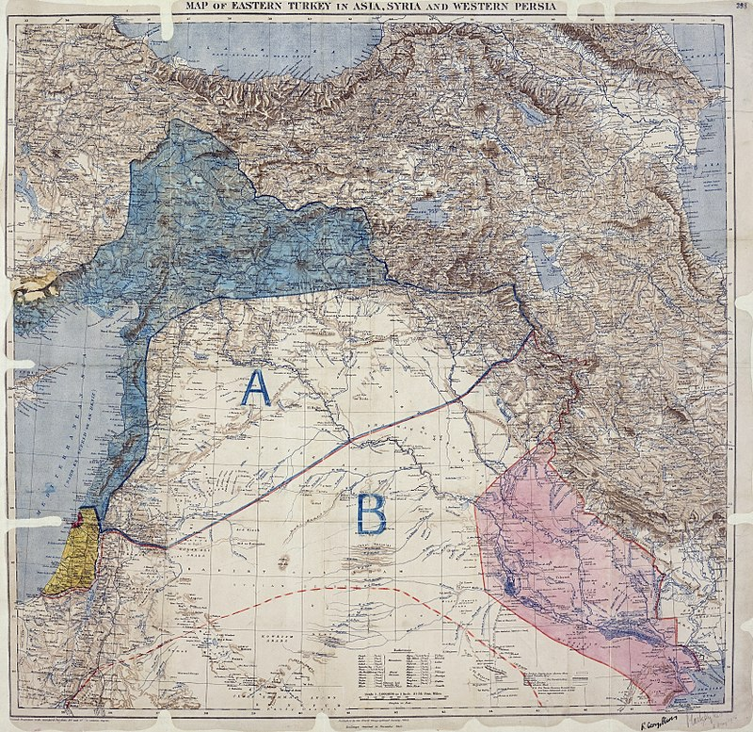
After the end of World War I, Lebanon had been released from ottoman rule in 1920 by French forces. The French promptly set up a government in Lebanon which granted the Lebanese a constitutional democratic parliamentary government. Politics and government were still greatly influenced by French interests in the region.
During WW2, the puppet Vichy government assumed control over Lebanon. Yet, in 1941 Lebanon and Syria are conquered by the forces of Free France under Charles de Gaulle and the British army.
Independence (22nd November 1943)
Under the new free France government, its leader Charles de Gaulle, under pressure, recognizes Lebanon's independence during the 22nd of November 1943. Elections are held and the new Lebanese government unilaterally abolishes the French mandate of Lebanon. The new government is arrested but after international pressure, French forces recognize Lebanon's independence and release the imprisoned government.
From this point onwards, things turn very ugly.
Wars
During the 1948 Arab-Israeli war, irregular militias crossed over from Lebanon to Israeli to skirmish Israeli forces. Lebanese troops never officially invaded Israel but aided the irregulars with artillery fire, supplies and air strikes. The war was a failure for Lebanon and the Arab league. Throughout the war, 100’000 Palestinian refugees fled to Lebanon.
During 1958, then President Camille Chamoun faced a Muslim insurrection advocating for Lebanon's entry into the Arab Republic 5,000 US marines were briefly dispatched to Beirut on 15 July. The president resigned and shortly after the crisis ended a new government was formed.
After Black September (6 September 1970 – 17 July 1971), the Palestinian Liberation Organization fled Jordan and moved to Lebanon. This caused a Palestinian insurrection in souther Lebanon that quickly escalated into civil war.
Civil war 13 April 1975 – 13 October 1990 (15 years and 6 months)
The civil war was fought between various belligerents. It was mainly fought between the government army, Christian and Muslim groups. After one year of civil war, the Syrian Arab Republic invades and occupies areas of Lebanon with the consent of the de jure Lebanese government.
The civil war ended with the disarmament of all militias, except Hezbollah. The war resulted in the death of around 100 thousand to 150 thousand people involved in the conflict.
The conflict ended with the Taif agreement, giving Christians and Muslims a more equal sharing of power in the Lebanese government.
Refugee Situation
As of 2019, there are 936`164 refugees in Lebanon. Taking into account the country`s 6.84 million inhabitants, refugees make up to almost 1/7th of all people living in Lebanon. The entire 563 million USD budget of the government, 57% of it was directed to taking care of refugees.
Hezbollah Problem
Hezbollah is a Islamic political and military organization founded in 1985. The organization was founded by Islamic clerics and Iran to fight against the Israeli occupation of south Lebanon in 1982 and it was an attempt by Iran to hinder the Israeli invasion of Lebanon. Israel throughout 1985 up until 2000 had occupied a souther strip of Lebanon called “South Lebanon security zone”.
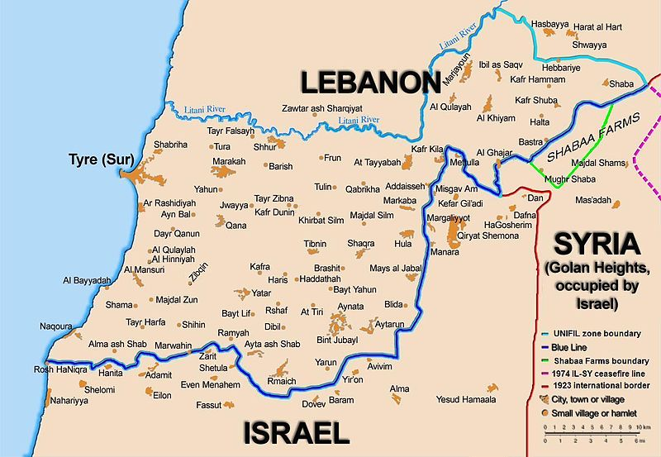This zone was under constant fighting between Israeli forces and the Hezbollah. Hezbollah’s objective was to drive out the Israeli invaders out of Lebanon. From 1985 to 2000 the Hezbollah and Israel fought over this region during The South Lebanon conflict. At the end of the conflict, the Hezbollah managed to force Israeli forces to abandon southern Lebanon. It is important to bear in mind that this occupation of southern Lebanon was under the consent of the Lebanese government, but with mounting bloodshed and turmoil in the region, the elected PM of Lebanon in 2000 Ehud Barak withdrew Israeli forces out of southern Lebanon.
After the withdraw of Israeli forces, the group reformed itself and became a political party. Since 1992 Hezbollah has been participating in Lebanese elections. The military wing of Hezbollah rebranded itself to the Lebanese resistance brigades. Ever since 1992, the LRB has been launching rockets from southern Lebanon over to Israeli. It has also been fighting radical Islamism like Isis and Al-Fatah.

Government, protests and Beirut Bay explosion
Lebanon is currently facing an economic and political crisis. The country has only experienced on average 1-2% GDP growth for the past 9 years. The government holds a public debt of 150% in relation to real GDP. Power outages are a common occurrence in Lebanon. The unemployment rate (2019) for those under 35 is 37%.
The blame of this economic disaster is often pointed at the Lebanese government and its political system. Transparency international scores Lebanon 28/100 in corruption perception and ranks Lebanon 137th least corrupt country in the world. 68% thought corruption had increased in the past 12 months (2019) and 41% of public users had paid a bribe the past 12 months (2019).
The religious division of power that has divided the Lebanese government is often criticized for being the responsible of creating a corrupt political elite. Foreign interference in politics have created factions inside the country. Iran and Russia have been backing and supporting Hezbollah since its dawn and the USA and Arab states.
The political and economic situations sparked protests that started in October of 2019. These protests were initially caused by a new proposition that would implement new taxes and increase existing ones. As time passed by, the protest grew in popularity. The protests turned into a protest against corruption and economic stagnation.
Conveniently, on the 4th of august 2020 a secret warehouse full of explosive nitroglycerin detonated at the port of Beirut. The explosion killed around 200 people and injured over 6’000 people. With a combination of protests and the explosion of the port, the entire Lebanese government resigned.

Important Security Council Resolutions on Lebanon:
S/Res/425 (1978) on Lebanon-Israel – Withdrawal of Israeli troops in Lebanese territory. Increase the number of United Nations Interim Forces from 40.000 to 60.000.
S/Res/520 (1982) on Lebanon-Israel - Condemnation of Israeli Incursions, withdrawal of Israeli troops out of Lebanon. Condemnation of the massacre of palestinian civilians in Beirut.
S/Res/1559 (2004) on Lebanon – All foreign troops must leave lebanon. Disarmament of Lebanese militias. Declare support for free and fair elections.
S/Res/1595 (2005) on UNIIIC establishment – International body created to investigate terrorism in lebanon.
S/Res/1701 (2006) on Lebanon-Israel – Ceasefire between Israel and Hezbollah.

Tips for delegations:
USA:
As the USA you should seek to destroy the influence the Hezbollah holds in Lebanon, as you deem it to be an Iranian proxy group. Furthermore, you must defend Israel’s past incursion into the country. Prevent Russia and China to exert more influence in Lebanon. Nation building is still open for negotiation after your attempt in Iraq. Further American ideals of liberty and democracy and show the world that the beacon of liberty is still burning.
Russia
From the frozen ports of Vladivostok to the Caucasus mountains and the artic Barents Sea, Russia is still a big player in International affairs. It is up to the delegate`s wish to set forth a path in Lebanon. It is advised to stop the increase of American influence at all cost and aid other movements hostile towards the USA. Secure Bashar al-Assad`s regime interests in Lebanon. Be wary of China as they might try to buy out your allies and overtake them. Seek to cause discontent among non-permanent members towards the USA. Forward Russia!
France
The cradle of Liberalism and Democracy, of liberty, fraternity and equality. France, although having gone through rough time, it is still exerts a huge influence in global affairs. As France you will go through some challenges and advantages. You will have to defend your colonial past as once rulers of Lebanon. Yet, you could also use your colonial past as an advantage to show commitment to the region and to the issue itself. Beware of other powers like the USA and Russia trying to overshadow you.
China
As the US`s new Archenemy, you will have to consolidate your strength and find alliances with the non-permanent Security Council Members. Although Russia is a go-to ally, beware of those Russians since the only thing you share is your common goal to deter America’s influence over the globe. It is time for china to make a new path for diplomacy in the middle east. Be flexible and resourceful. Break the chains of the proletariat from the ruling classes and finish the world revolution!
United Kingdom
From Britannia rule the waves to ruling an island and a half in Europe, Britain's influence over world affairs has gone through a rough ride. Yet, don’t let this discourage you. Britain is still Europe`s second largest economy and holds great alliances with the west. Be ready to defend yourself from any negative criticism from the Sykes-Picot agreement. Use the USA in your advantage and do not become their puppet. Remember, The sun never sets on the British Empire!
Germany
Europe’s biggest economy positioned in the middle of the continent, as Germany you will have a big sway with European nation’s. Although having a very developed economy and nig influence in the European Union, you are not part of the G5 but you have the sufficient levering power to act like one. Reach your European neighbors like France and the UK. Use the USA and Russia for your own interests and play them against one another.
Estonia
The founders of Skype and at the doorsteps of Russia, this Nordic country is under the constant threat of Russian influence. As Estonia, do not feel afraid to use your geographical position to negotiate against Russians. AS a NATO member, it will be beneficial for you to serve as an great strategic position for your alliance.
Indonesia
As the biggest, in terms of population, Muslim country in the world it will fall upon your hands to represent Muslims in the Security Council. Be watchful of past colonial powers and their actions as you once where victim of their occupation. Wield your position wisely as Islam is one of the biggest religions in Lebanon and find sympathy with Islamic groups.
Niger
Do not feel intimidated by the strength and wealth of your colleges as you have a very peculiar hook on a G5 nation. Niger has one of the world’s biggest Uranium supply and Nigerian Uranium supplies roughly 20% of all energy production in France. Having the French rely on you might come handy fory you.
Saint Vincent and the Grenadines
As a Caribbean nation, it might come as a surprise that your archipelago has a strong hook on the USA. Your country is a so called “Tax haven” where many companies and wealthy people store their wealth to avoid taxation. The main costumers of this benefit are American companies and people. Holding much capital of a G5 country could come handy when dealing with the USA.
South Africa
The rainbow nations is between the crossroads of Russian-Chinese alliances and US interests. As a member of the BRICS, South Africa is pledge to have economic ties with nations in this bloc (Brazil, Russia, India and China).
Belgium
One of the homes of the European Union, Belgium is between the crossroads of France and Germany. As an EU and NATO member, relations with Germany, France or Britain could become useful if you can negotiate efficiently. As a nation with a complex political system, it is in the delegate’s best interests to pursue peaceful approaches and take a stance of neutrality.
Tunisia
Being the only North African nation in the SC, it is Tunisia’s responsibility to further its interests and the interests of the region. As a former French colony, you could give examples and models as to how to structure a post-colonial nation. Seek alliances with France as your former colonial master but remind them of their dark colonial past to keep them at bay.
Viet Nam
From its independence struggle against both westerners and easterners, Viet Nam has found itself in a tricky spot. The benefits that could arise for Viet Nam from the Lebanon might not be many. Although beware of the G5 members. Keep in mind your independence struggles against NATO members and ensuing wars with the Chinese. Be ready to call out against G5 powers from nation building and foreign intervention in Lebanon. Remember the 60`s and 70`s when foreign intervention destroyed your country.

Barr, James, 1976- (27 October 2011). A line in the sand : Britain, France and the struggle for the mastery of the Middle East. London.
“USIPeace Briefing.” Lebanon's Confessionalism: Problems and Prospects: USIPeace Briefing: U.S. Institute of Peace, 30 Mar. 2006, web.archive.org/web/20080709034419/www.usip.org/pubs/usipeace_briefings/2006/0330_lebanon_confessionalism.html.
Morris, Benny (April 2008). 1948: A History of the First Arab-Israeli War. Yale University Press.
Pike, John. “Military.” Operation Blue Bat, www.globalsecurity.org/military/ops/blue_bat.htm.
Becker, Jillian (1984). The PLO: The Rise and Fall of the Palestine Liberation Organization.
“The World Factbook: Lebanon.” Central Intelligence Agency, Central Intelligence Agency, 1 Feb. 2018, www.cia.gov/library/publications/the-world-factbook/geos/le.html.
“Population, Total - Lebanon.” Data, data.worldbank.org/indicator/SP.POP.TOTL?locations=LB.
UN Press Release SC/6878. (18 June 2000). Security Council Endorses Secretary-General's Conclusion on Israeli Withdrawal From Lebanon As of 16 June.
“The World Factbook: Lebanon.” Central Intelligence Agency, Central Intelligence Agency, 1 Feb. 2018, www.cia.gov/library/publications/the-world-factbook/geos/le.html.
“Explainer: Why Is Lebanon in an Economic and Political Mess?” Reuters, Thomson Reuters, 6 Nov. 2019, www.reuters.com/article/us-lebanon-protests-causes-explainer-idUSKBN1XG260
Ibrahim, Arwa, et al. “Second Day of Protests as Anger over Beirut Explosion Grows: Live.” Middle East | Al Jazeera, Al Jazeera, 9 Aug. 2020, www.aljazeera.com/news/2020/08/hundreds-protesters-injured-anger-simmers-beirut-live-200808234355971.html.
“Security Council Resolutions on Lebanon.” UNSCOL, 29 Aug. 2020, unscol.unmissions.org/security-council-resolutions-lebanon.

