IBERIAN MUN Security Council
Officer Report 2020

The question of holding international bodies and Member States responsible for their involvement and/or measures towards Covid-19.

Covid 19 pandemic, also known as the coronavirus disease 2019. The disease was first found in Wuhan, China and was declared an emergency by the WHO (World Health Organization) in January of 2019 and was declared a pandemic in May 2019. Countries were forced to take measures in order to limit the amount of covid 19 cases.
Since COVID-19 pandemic has started in China, some people are trying to make an argument and that China is at fault for a rapid spread of covid 19. Some people such as Samuel Armstrong (law expert) and Miller believe that china should face some form of repercussion: “These regulations require a country to report a pandemic scenario to the World Health Organization (WHO) and share certain data within 72 hours. China’s apparent failure to uphold this duty would be the core basis of any complaint,” – Armstrong. “China violated its legal duties under the International Health Regulations to convey accurately the extent of the virus inside China. China intentionally hid information, thereby endangering us all,” – Kraska. (professor at the Stockton Center for international law) While Kraska and Armstrong seem to agree that China can be sued for the spread of COVID 19 Miller has a slightly different perspective: “States might punish China by restricting trade ties, imposing sanctions, naming and shaming, passing a resolution in the UN, restricting travel to and from China, downgrading ties, or by other symbolic gestures. But I'm not aware of any meaningful or enforceable legal mechanisms anyone could use against China,” – Miller.
Countries such as the UK, Belgium, Spain and Italy (along with the United states) had one of the worst responses to the pandemic. Although it could be understandable why Spain and Italy had such a low efficiency, due to the fact that they were one the first European nations to be hit by the pandemic, it seems as the UK is an outlier. Since it was hit much later and had enough time to prepare correct measures. "The countries that rank at the bottom of our index either did not have time to prepare for the pandemic (Spain, Italy), or made dubious policy choices to combat the pandemic. “ "For instance, an insufficiently fast and coordinated response, an initial lack of testing capacity, and a decision to suspend track and trace in early March explain why the UK became an outlier." – Agathe Demaris. (the index that is referred to in this quote was used to rank quality and the effectiveness of the countries response to the pandemic.).

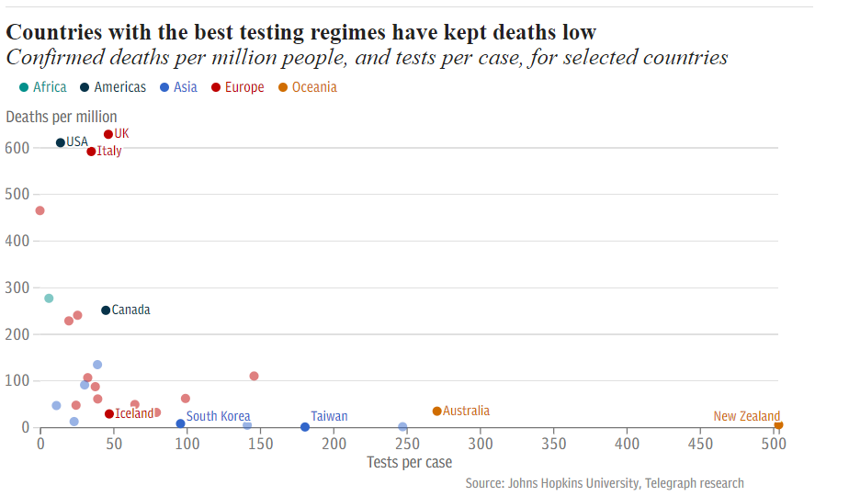
Some of the early Mistakes that the UK has made include: delaying the purchase of equipment and testing materials, miss informing/different messages about health practices and delaying and enforcing (initially) social distancing, lock downs and other kinds or restrictions and precautions. One of Britain’s first mistake (according to Ashton) was not calling a meeting when the first case of COVID 19 was detected. “Because Johnson didn’t chair the meeting at the beginning of February, the government missed the opportunity to see that they needed to be ready to do lots of testing, that they would need to sort out stocks for personal protection and for oxygen and other supplies,” – Ashton. This decision caused shortage in the equipment needed for treating and limiting COVID 19.
Belgium among the OECD countries had the worst response to the pandemic. This was analyzed by putting the three risk factors: international arrivals, number of people aged 65 or hire and obesity prevalence; against three measures of the response quality: testing, death rates caused by covid 19 and supply of anti COVID 19 health care. With the rating of 2.11 , Belgium has ranked at the bottom and on 17th June Belgium had the biggest death rate per capita. (according to Our World Data).
While US, has a much larger death count due to COVID-19, it said to be expected, due to the fact that some countries have much higher population count to begin with. US is only making the situation worse with constant protests, since, even if the protestors are wearing a mask ; standing in a large crowed over a long period of times increases the risk of the virus being transmitted.

Some interesting links in the bibliography including a link that describes the response and measures taken by every single country.
Debate tips: clearly there was some arguments to sanction/sue China, so some member states could definitely attempt that. Also, we can clearly see that some international bodies did/are doing very poorly with their measures to prevent COVID-19 spread; the debate should be focused on holding those accountable, and ideally trying to improve/fix the situation in those member states.
Bibliography:
Alexis C. Madrigal, Robinson Meyer. “America Is Giving Up on the Pandemic.” The Atlantic, Atlantic Media Company, 19 Aug. 2020, www.theatlantic.com/science/archive/2020/06/america-giving-up-on-pandemic/612796/.
Brueck, Hilary. “Photos from 10 Countries around the World Show Why Most Americans Say They Are 'Embarrassed' by the US Coronavirus Response.” Business Insider, Business Insider, 5 Sept. 2020, www.businessinsider.com/photos-us-has-the-worst-coronavirus-response-in-the-world-2020-9.
“China Can Be Held Accountable for Virus: Experts.” Anadolu Ajansı, www.aa.com.tr/en/asia-pacific/china-can-be-held-accountable-for-virus-experts/1825139.
“COVID-19 Pandemic.” Wikipedia, Wikimedia Foundation, 19 Oct. 2020, en.wikipedia.org/wiki/COVID-19_pandemic.
Perrigo, Billy. “How the U.K. Mismanaged Its Coronavirus Response.” Time, Time, 17 Apr. 2020, time.com/5823382/britain-coronavirus-response/.
“Policy Responses to COVID19.” IMF, www.imf.org/en/Topics/imf-and-covid19/Policy-Responses-to-COVID-19.
“Policy Responses to COVID19.” IMF, www.imf.org/en/Topics/imf-and-covid19/Policy-Responses-to-COVID-19.
Rigby, Jennifer. “UK Response to Coronavirus Pandemic One of the Worst in the World, Report Finds.” The Telegraph, Telegraph Media Group, 17 June 2020, www.telegraph.co.uk/global-health/science-and-disease/uk-response-coronavirus-pandemic-one-worst-world-report-finds/.
Taylor, Chloe. “Belgium Had the Worst Response to the Coronavirus Crisis among OECD Countries, EIU Says.” CNBC, CNBC, 17 June 2020, www.cnbc.com/2020/06/17/belgium-had-the-worst-response-to-coronavirus-crisis-among-oecd-eiu.html.
“‘We Need to Act Now to Avoid the Worst Impacts of Our Efforts to Control the Pandemic.’” United Nations, United Nations, www.un.org/en/coronavirus/we-need-act-now-avoid-worst-impacts-our-efforts-control-pandemic.

